AWS MLOps: End to end Machine Learning workflows by using following:

* Amazon Sagemaker Pipelines,
* Amazon Sagemaker Model Registry
* Amazon Sagemaker Clarify

With Sagemaker Pipeline, you can automate different steps of the ML Workflows:

* Data Loading, Data Transformation, Training, Tuning, Evaluation, Deployment

Sagemaker Model Registry allow you to track model versions, their metadata such as use case grouping and model performance metrics baselines in a central repository where it is easy to choose the right model for deployment based on business requirement.

Sagemaker Clarify provides great visibility into your training data and models so you can identify and limit bias and explain predictions.

Build Pipeline component:

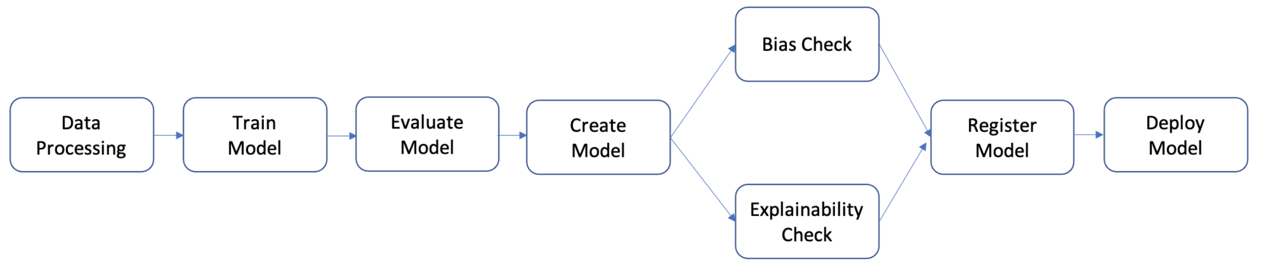

Data Processing:

1. Data processing step: Runs a SageMaker Processing job using the input raw data in S3 and outputs training, validation, and test splits to S3.
2. Training step: Trains an XGBoost model using SageMaker training jobs with training and validation data in S3 as inputs, and stores the trained model artifact in S3.
3. Evaluation step: Evaluates the model on the test dataset by running a SageMaker Processing job using the test data and the model artifact in S3 as inputs, and stores the output model performance evaluation report in S3.
4. Conditional step: Compares model performance on the test dataset against the threshold. Runs a SageMaker Pipelines predefined step using the model performance evaluation report in S3 as input, and stores the output list of pipeline steps that will be executed if model performance is acceptable.
5. Create model step: Runs a SageMaker Pipelines predefined step using the model artifact in S3 as an input, and stores the output SageMaker model in S3.
6. Bias check step: Checks for model bias using SageMaker Clarify with the training data and model artifact in S3 as inputs and stores the model bias report and baseline metrics in S3.
7. Model explainability step: Runs SageMaker Clarify with the training data and model artifact in S3 as inputs, and stores the model explainability report and baseline metrics in S3.
8. Register step: Runs a SageMaker Pipelines predefined step using the model, bias, and explainability baseline metrics as inputs to register the model in the SageMaker Model Registry.
9. Deploy step: Runs a SageMaker Pipelines predefined step using an AWS Lambda handler function, the model, and the endpoint configuration as inputs to deploy the model to a SageMaker Real-Time Inference endpoint.

**Cardiovascular Disease Prediction:** This solution helps cardiologist to predict diseases at an early stage and treat the patient accordingly. Aim of the problem is to detect the presence or absence of cardiovascular disease in person based on the given features.

DataSet: The dataset used to solve this problem is contains following features:

* Objective Features (i.e: Age, Height, Weight, Gender),
* Examination Feature (i.e: Systolic blood pressure, Diastolic blood pressure, Cholesterol, Glucose),
* Subjective Feature (i.e: Smoking, Alcohol intake, Physical activity)

Solution: Our model is able to predict the person having a cardiovascular disease or not.

Project Life Cycle:

* Automate data loading, data transformation, training, tuning, evaluation, and deployment by using ML Workflow.
* Store newly generated model into Model Registry.
* Use Sagemaker Clarify for visibility purpose and track data quality, model quality.
* Launch new model by using shadow testing first.
* Implement governance of ML Model.

KPI: Precision, Recall, F1 Score, Confusion Metrix



